AWS VPC PEERING

Mini Project Report

1. Abstract
This project demonstrates the implementation of Virtual Private Cloud (VPC) Peering in Amazon Web Services (AWS). It connects two separate VPCs and enables private communication between resources in different virtual networks. Terraform and AWS CloudFormation are used to define and manage cloud infrastructure. The project also uses EC2 instances, route tables, security groups, and a Bastion host to demonstrate secure network connectivity.

2. Introduction
Amazon Web Services (AWS) provides cloud computing services that allow users to create and manage virtual networks. A Virtual Private Cloud (VPC) is a logically isolated network in AWS.
VPC Peering establishes a private connection between two VPCs, allowing resources to communicate using private IP addresses. In this project, two VPCs are connected through a peering connection, and routing and security rules are configured to control communication.

3. Problem Statement
To design and implement a secure network connection between two AWS VPCs using VPC Peering, appropriate route tables, security groups, EC2 instances, and a Bastion host.

4. Aim
To establish private communication between two AWS VPCs and understand secure cloud networking using Terraform and AWS services.

5. Objectives
- Create two separate AWS VPCs.
- Configure public and private subnets.
- Establish a VPC Peering connection.
- Configure route tables for communication between the VPCs.
- Deploy EC2 instances for testing network connectivity.
- Use a Bastion host for controlled SSH access.
- Configure security groups using restricted access rules.
- Test connectivity and understand the effect of firewall rules.
- Clean up cloud resources after testing.

6. Technologies Used
- Amazon Web Services (AWS): Cloud infrastructure platform.
- Amazon VPC: Creation of isolated virtual networks.
- Amazon EC2: Virtual machines used for testing.
- VPC Peering: Private communication between two VPCs.
- Terraform: Infrastructure as Code (IaC) tool.
- AWS CloudFormation: Template-based infrastructure configuration.
- Security Groups: Control of inbound and outbound traffic.
- Python: Used to generate the project report.
- HTML: Used to prepare the report layout.

7. System Architecture
The project consists of two VPCs:
- VPC A: Uses the network range 10.10.0.0/16.
- VPC B: Uses the network range 10.20.0.0/16.
VPC A contains a public subnet, a private subnet, and a Bastion host. VPC B contains a private subnet and an application EC2 instance. A VPC Peering connection links the two networks.
The application instances are designed to use private IP addresses rather than direct public internet access. Administrative SSH access is routed through the Bastion host.

8. Working Principle
The project works through the following steps:
- VPC Creation: Two isolated virtual networks are created in AWS.
- Subnet Configuration: Public and private subnets are configured according to the network design.
- Internet Gateway: An Internet Gateway provides internet routing for the public subnet in VPC A.
- VPC Peering: A peering connection is created between VPC A and VPC B.
- Route Configuration: Route tables are configured to send traffic for the other VPC through the peering connection.
- EC2 Deployment: A Bastion host and two application instances are configured.
- Security Group Configuration: Rules control SSH and ICMP traffic between authorized systems.
- Connectivity Testing: Network communication is tested, and a controlled security-group rule change demonstrates how traffic can be blocked.
- Resource Cleanup: The cloud resources are removed after testing to avoid unnecessary charges.

9. Simple Block Diagram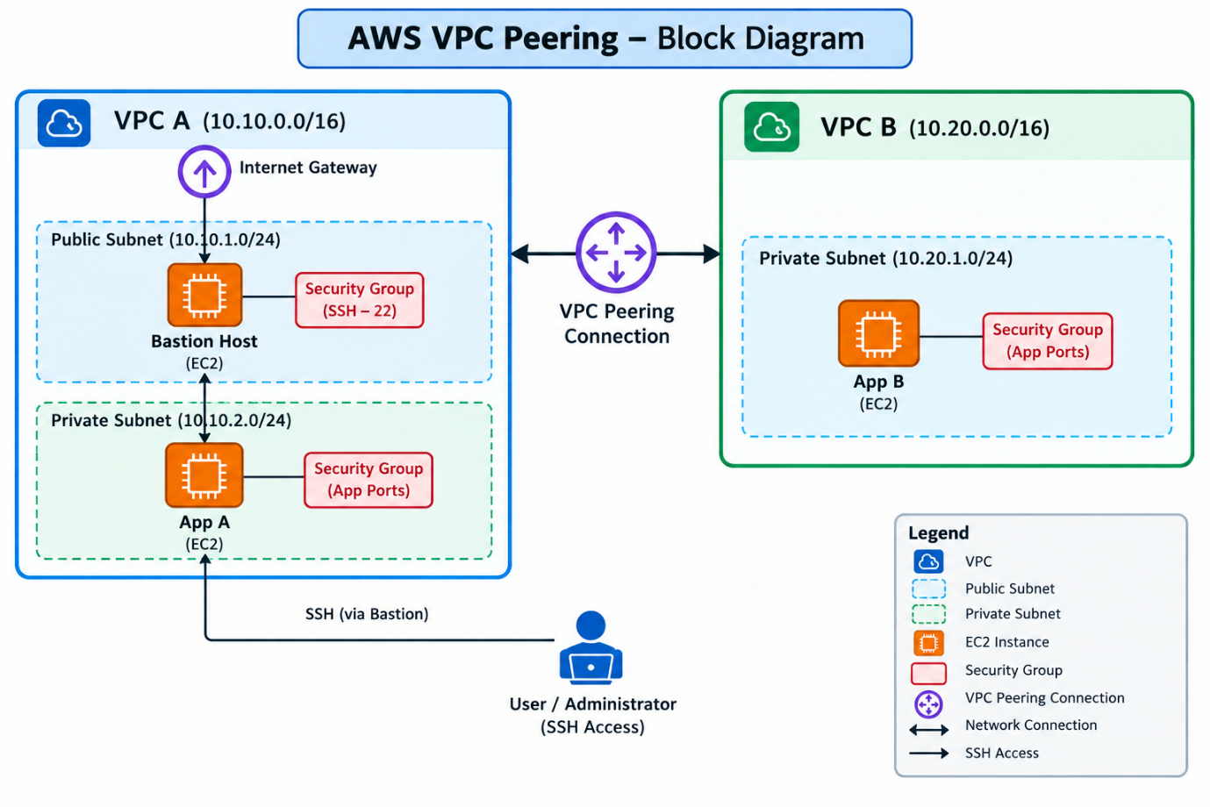

10. Role of Terraform Code
The Terraform configuration defines the infrastructure required for the project. It includes VPCs, subnets, route tables, the peering connection, security groups, EC2 instances, and outputs.
The variables file defines configurable values such as AWS region, EC2 key pair name, administrator IP range, and instance type. The outputs file provides important resource identifiers and the Bastion host's public IP address.

11. Role of AWS CloudFormation
The CloudFormation template provides another method for defining AWS infrastructure through a YAML file. It includes configurable parameters such as the EC2 key pair, administrator IP range, and instance type.
The administrator IP parameter is intended to restrict SSH access to a trusted address. For secure deployment, the default 0.0.0.0/0 should be replaced with the administrator's trusted public IP in /32 CIDR notation.

12. Security Features
The project demonstrates several important security practices:
- Private IP communication between VPCs.
- Restricted SSH access through a Bastion host.
- Security-group rules for controlling network traffic.
- Separation of public and private subnets.
- Explicit routes for communication between VPCs.
- Controlled testing of firewall restrictions.
- Removal of resources after the lab is completed.

13. Results and Discussion
The code defines the infrastructure for connecting two VPCs using a peering connection. It configures routing between the networks and uses security groups to control communication.
The project also includes a report-generation script that inserts infrastructure details and checkpoint screenshots into an HTML report. The generated HTML can be used to create a formatted PDF report.
The supplied code and repository changes describe the intended configuration and testing process. Actual successful deployment and connectivity should be confirmed using AWS console evidence or test results.

14. Applications
- Communication between applications in separate VPCs.
- Private connectivity between development and testing environments.
- Secure access to private cloud instances.
- Learning AWS networking and cloud security.
- Understanding Infrastructure as Code using Terraform.

15. Advantages
- Enables private communication between VPCs.
- Supports network separation and organized infrastructure.
- Reduces the need to expose application instances directly to the internet.
- Allows repeatable infrastructure deployment through code.
- Helps demonstrate routing and security-group behavior.

16. Limitations
- VPC Peering is not transitive; a third VPC cannot automatically use the connection to reach the other two VPCs.
- Routes must be configured correctly on both sides.
- Security groups must allow the required traffic.
- Overlapping VPC CIDR ranges can prevent peering.
- Cloud resources may incur charges while running.
- The provided configuration requires appropriate AWS permissions and a valid EC2 key pair.

17. Future Scope
The project can be extended by adding centralized monitoring, automated connectivity tests, CloudWatch alerts, and improved security validation. AWS Transit Gateway may be considered when connecting multiple VPCs. Terraform variables and deployment checks can also be improved to make the infrastructure safer and easier to maintain.

18. Conclusion
This project explains how to establish private communication between two AWS VPCs using VPC Peering. It demonstrates the importance of route tables, subnets, EC2 instances, security groups, and Bastion-host access in cloud networking.
The project also shows how Terraform and CloudFormation can help automate infrastructure configuration. It provides practical learning about cloud network design, access control, connectivity testing, and resource cleanup.

19. References
- Amazon Web Services (AWS), Amazon VPC Documentation — https://docs.aws.amazon.com/vpc/
- Amazon Web Services (AWS), VPC Peering Documentation — https://docs.aws.amazon.com/vpc/latest/peering/
- HashiCorp, Terraform Documentation — https://developer.hashicorp.com/terraform/docs
- Amazon Web Services (AWS), Amazon EC2 Documentation — https://docs.aws.amazon.com/ec2/
- Amazon Web Services (AWS), AWS CloudFormation Documentation — https://docs.aws.amazon.com/cloudformation/

